***Crystal dandelion***

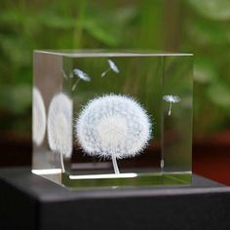

*The dandelion crystal is made of K9 crystal material. You can also purchase an additional color-changing LED light base for a more shimmering light effect. Crafted with advanced 3D laser engraving technology. Crystal dandelion is suitable as a meaningful girlfriend gift, gift for close friends, colleagues, ...*